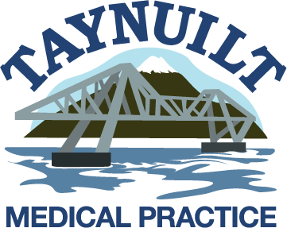
New Patient Questionnaire

For patients aged
16 and over

Welcome to your new Medical Practice. We will be getting your old medical records from your previous doctor. This may take a number of weeks, so in order to look after you it would be helpful if you could answer the following questions.

Personal Details
Name …………………………………………
D.O.B. ………/…………/..………………
Telephone (Home) ……………………….
(Mobile) ………………………….
Email …………………….…………………..
Preferred method of contact:
Home tel □ Mobile □ Email □ Post □

Family History
Have any close relatives had:
- Stroke Yes □ No □
Heart disease, heart
attack or angina Yes □ No □
- Diabetes Yes □ No □
- Asthma Yes □ No □
- High Blood Pressure Yes □ No □
If yes which relative ……………….………
Other illnesses running in the family
……………………………………………….
……………………………………………….

Medical History / Operations
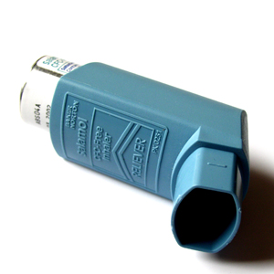

Have you ever had:

Asthma Yes □ No □
Diabetes Yes □ No □
Fits/Faints/Seizures Yes □ No □
Mental ill health Yes □ No □
Other serious illnesses Yes □ No □
Operations Yes □ No □

If yes, please detail below:

Date Problem/Operation

- ……………………………………………
- ……………………………………………
- ……………………………………………
- ……………………………………………
- ……………………………………………

Allergies
Please list any significant allergies (e.g. medicines) below
…………………………………………………
…………………………………………………
………………………………………………...


Medications
Please list any regularly prescribed medications below
- ……………………………………………
- ……………………………………………
- ……………………………………………
- ……………………………………………
- ……………………………………………

Health
Smoker Yes □ No □
Amount …………………………….……….
Past smoker Yes □ No □ Amount …………………………..…..…….
Year stopped ………………………………
Alcohol – Units per week…….…………….
Height ………..…. Weight ………………
Exercise:
None □ Light □ Moderate □ Heavy □

Carers
Are you a carer? Yes □ No □
If yes, please give name of person you care for.
………………………………………………
Do you have a carer? Yes □ No □
If yes, please give name of carer.
………………………………………………

- KIS. This allows clinicians from hospitals and ambulance crew to access your GP medical record. Please tick if you consent to us sharing this information.

Health Checks

We invite all new patients to attend a new patient health check with one of our practice nurses when you register with the practice.

Thank you for taking time to complete this form

Please hand this to the receptionists when you have completed it

